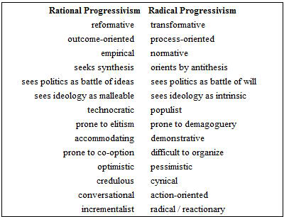
Progressive Legislation
1901 | New York State Tenement House Law | Requires fire escapes, lights in dark hallways, a window in each room
1902 | Maryland Workmen's Compensation Law | Provide benefits for workers injured on the job
 | Wisconsin Direct Primary Law | Allows voters to select candidates
 | Oregon Initiative and Referendum laws | Gives voters power to initiate legislation and vote on important issues
 | Newlands Act | Funds irrigation projects in West
1903 | Oregon women's labor law | Limits work for women in industry to 10 hours a day
 | Elkins Act | Strengthens Interstate Commerce Act
1906 | Hepburn Act | Authorizes Interstate Commerce Commission to set maximum railroad rates
 | Pure Food and Drug Act | Prohibits sale of adulterated or fraudulently labeled foods and drugs
 | Meat Inspection Act | Enforces sanitary conditions in meatpacking plants
1910 | Mann Act | Prohibits interstate transportation of women for immoral purposes
1913 | 16th Amendment | Authorizes federal income tax
1915 | Seaman's Act | Regulates conditions of maritime workers
1916 | Federal Farm Loan Act | Provide farmers with low interest loans
 | Federal Child Labor Law | Barred products produced by children from interstate commerce (declared unconstitutional in 1918)
1919 | 18th Amendment | Prohibited sale and production of intoxicating liquors
1920 | 19th Amendment | Gave women the right to vote

